**Assignment 5 – Meanlify Research**

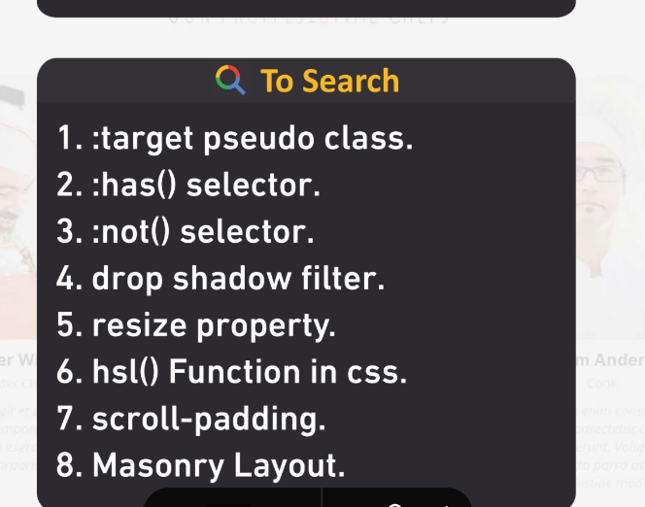

**1. :target Pseudo-Class**

* Used to style the element targeted by a URL hash.

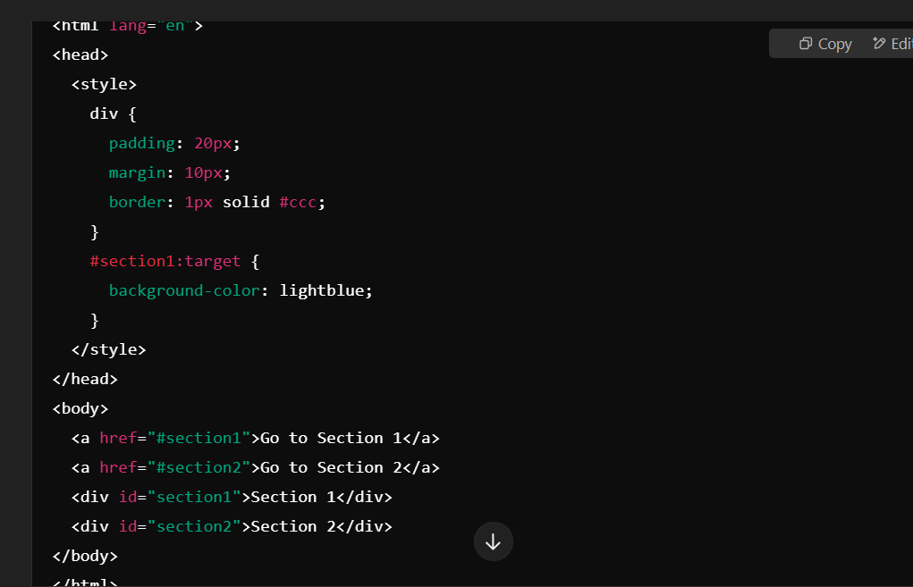

### 2. :has() ****Selector****

* Selects an element containing a specific child or descendant.

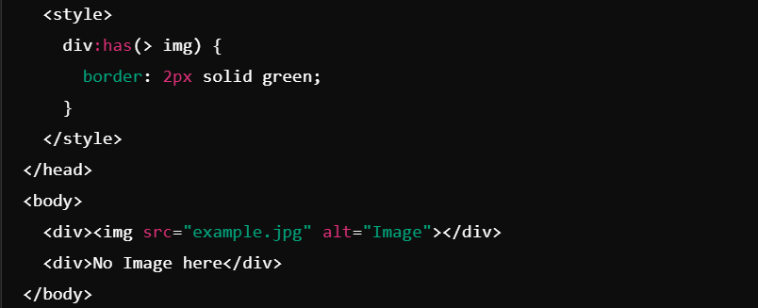

**3. :not() Selector**

* Selects all elements except the ones matching the condition.

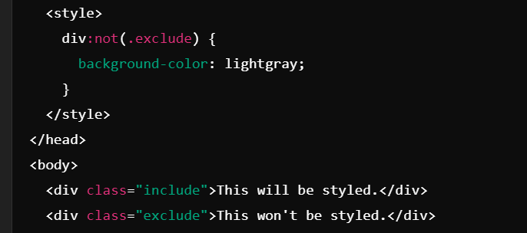

### 4. drop-shadow ****Filter****

* Applies a shadow effect to an element, similar to box-shadow, but specifically for images and elements.

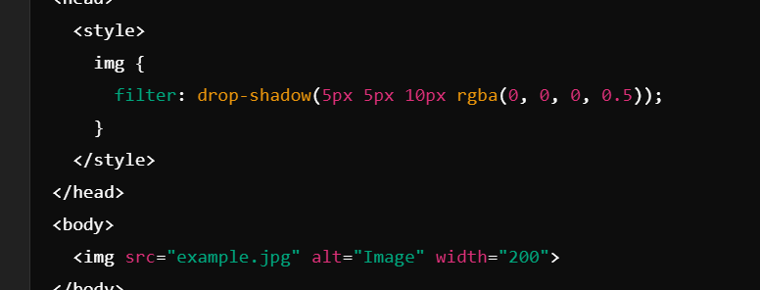

### 5. resize ****Property****

* Allows or restricts resizing of an element.

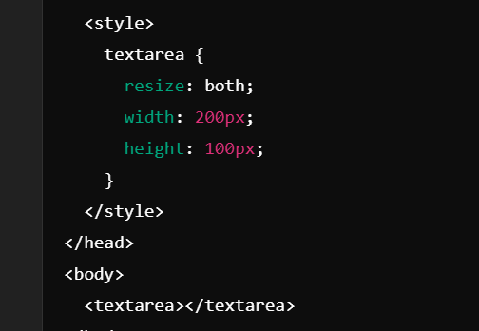

### 6. hsl() ****Function****

* Defines colors using hue, saturation, and lightness.

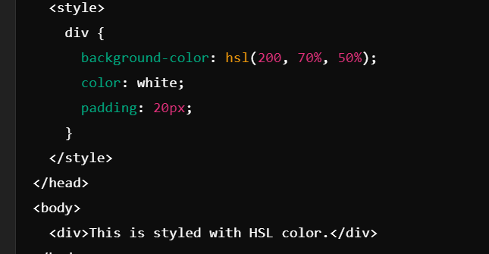

Scroll Padding

### ****Masonry Layout****

The Masonry layout is a grid layout technique commonly used to arrange items with variable heights, such as in image galleries or blog posts. Unlike a regular grid layout where items align uniformly, a masonry layout stacks items vertically, minimizing vertical gaps.

#### How It Works:

* Masonry layouts don’t rely on rows or fixed heights.
* They place items in the most compact arrangement possible, filling available vertical space.